These are notes to accompany the video series:

***R for epidemiologists (beginners)***

**Watch it at:** [**www.sva.se**](http://www.sva.se)

And use this document as a guide to make your notes

For your reference: <http://www.r-project.org/> (Search 🡪 R site search)

> citation()

## Installing R and installing RStudio

R: <http://cran.r-project.org/bin/windows/base/> (install first)

R Studio: <http://www.rstudio.com/products/rstudio/download/>

## Introduction to the interface and R syntax

* R as a big calculator
  + 1+1, 6*7
  + > lines (command prompt) versus answers (bracket numbered lines)
  + Decimals with . 10.5 10,5
  + Assigning values to variables (we’ll define ***objects*** more precisely later)
    - var = 2 versus var <- 2
  + Breaking up over multiple lines
  + ESCape
  + Arrow up
* Simple mathematical operators: + - * / ^ ()
* Some other mathematical functions
  + Integer quotients: 119%/%13 [1] 9
  + Modulo (remainder): 119%%13 [1] 2
* Object names
  + Case-sensitive: var<-2 versus Var<-24
  + Cannot start with numbers
  + Cannot have spaces: var_1; var.1

## Let us better stick to Rstudio…

* Console
* Bottom right: files, plots, packages
* Top right: Environment
* Editor – write and save scripts

## Continuing with basic math in R:

Script used in **video1**:

#### Basic mathematical operations

119%/%13

119%%13

x <- 10

log(x)

exp(x)

sqrt(x)

12/7

floor(12/7)

ceiling(12/7)

y <- 12/7

floor(y)

ceiling(y)

round(12/7)

round(12/7, digits=1)

round(12/7, digits=2)

### Logical tests

3 < 4

248%%2==0

0 == 0.000000000000001

a <- 6*7

(b = (a==42))

a <- 2

b <- -2

a > 0

(a>0)&(b>0)

(a>0)|(b>0)

a<2

a<=2

* Logical values

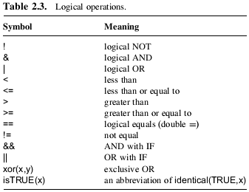

Source: Michael J. Crawley. The R Book.

* + 15%%2==0 (test if odd or even)
* Simple mathematical functions

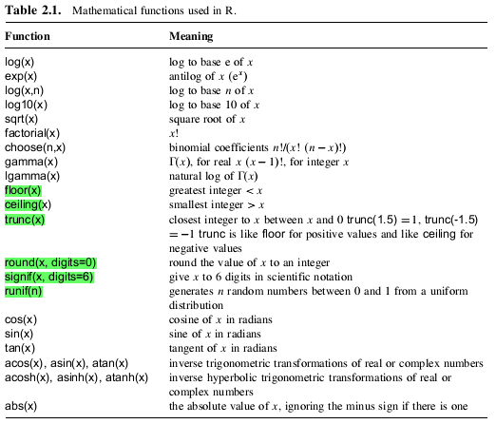

Source: The R book, Michael J. Crawley.

## Number and vectors in R, simple manipulations

**(The script used in the video is pasted in the next page)**

* Create vectors
* Paste from clipboard (COLUMN format): x<- scan()
* Elements can be non-numeric; but all must be the same type
* Vector index
  + Single
  + Multiple
  + range
  + Duplicate
  + Out-of-order
  + Out of bond index
  + Negative index
* Basic operations
* Recycling
* Which x logical tests

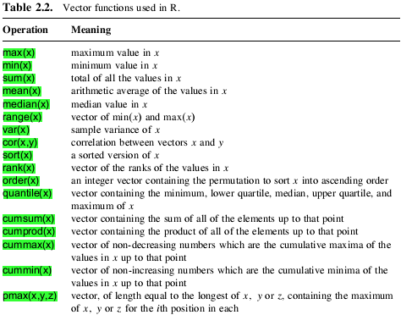

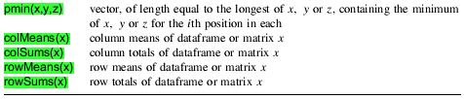

Source: The R book, Michael J. Crawley.

### Vectors: script used in video 2

#Creating vectors

(var1 <- 1:15)

(var2 <- c(2,3,7))

(x <- c(var1,var2))

(y <- c(1:5,rep(6,4),7:8))

#Pasting from clipboard

myExcel.data <- scan()

#Non numerical data types

(fruits <- c("apples","oranges","grapes"))

(mix <- c(1,"apple",3,4))

numbers <- -5:5

test <- numbers>0

#Indexing

1:200

numbers[3]

numbers[3:5]

fruits[c(1,3)]

liked.fruits <- fruits[c(1,3)]

liked.fruits <- fruits[-2]

fruits

fruit[3] <- kiwis

fruit[3] <- "kiwis"

liked.fruits

liked.fruits[3] <- "kiwis"

cows.tested <- c("daisy","nora","earTag1267")

cows.tested[4] <- "mimosa"

cows.tested <- c(cows.tested,"princess")

cows.tested[10] <- "prima"

cows.tested[11]

liked.fruits

eaten.fruits <- liked.fruits[c(1,3,1,1)]

liked.fruits[c(3,1)]

a<- 1:10

b<- 1:11

a+b

#Operations with vectors

x <- 1:15

x*2

a<- 1:10

b<- 11:20

a+b

b<-10:20

a+b

c <- a+b

numbers <- -5:5

numbers>0

which(numbers>0)

result1 <- numbers>0

result2 <- which(numbers>0)

result3 <- numbers[which(numbers>0)]

result4 <- numbers[numbers>0]

result1==result2

result3==result4

#propertis of vectors

length(numbers)

class(numbers)

class(result1)

class(cows.tested)

#Functions applied to vectors

a <- 1:10

(b <- a/3)

floor(b)

max(b)

min(b)

mean(b)

(x <- rpois(15, 5))

sort(x)

order(x)

(x <- c(1,5,3,4,2))

(groups <- c("a","b","c","d","e"))

groups[order(x)]

## Matrices

* Building
  + Using matrix()
  + From vectors
* Indexes
* dim()
* cbind() rbind()
* Matrix math

## Objects and their properties

* Character
* length() and dim()
* class()

## Factors

* as.factor() x as.integer() x as.character()
* ordered factors: ordered()

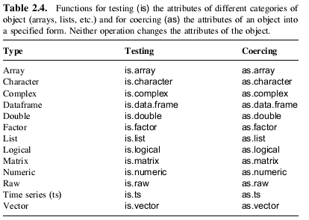

Source: The R book, Michael J. Crawley.

## Data frames

* data frames versus matrices
* categorical variables - factors
* data.frame(); as.data.frame()
* cbind(), rbind()
* Rownames(), colnames()
* str()
* summary()
* table()

## Arrays

* array()
* dim(); dimnames()
* indexing

## Lists

* list(); as.list()
* ~~dim();~~ length()
* indexing

### Script used in video3:

## Building matrices in R

#Using matrix()

M = matrix(

c(2, 4, 3, 1, 5, 7),

nrow=2,

ncol=3,

byrow = TRUE)

matrix(1:12,3,4)

matrix(1:12,ncol=4,nrow=3)

#From vectors

ID <- 1:15

weight <- rnorm(15,mean=75,sd=4)

height <- norm(15,

mean=1.65,sd=0.2)

study.group <-matrix(

c(ID,weight,height), ncol=3,byrow=FALSE)

study.group <- cbind(

ID,weight,height)

dim(study.group)

study.group <- rbind(study.group,

c(16,7,1.6))

dim(study.group)

#Indexing

study.group[3,2]

study.group[3,2:3]

study.group[3,c(1,3)]

study.group[,2]

study.group[3,]

study.group[16,2] <- 87

#Matrix math

M*2

M+N

M*N

# Objects and their properties

class(study.group)

cowName <- c("Daisy","Bia",

"Mimosa","Princess", "lili","Nora","earTag1378",

"ceci","kiki","Amelia")

Lactation <- c(1,2,5,3,2,2,4,1,4,3)

Vaccinated <- c(TRUE,FALSE,FALSE,

TRUE,TRUE,TRUE,TRUE,

FALSE, TRUE,TRUE)

ELISA <- c(0.1,0.5,0,2.5,

1.2,0,1.5,0,0,2.5)

class(cowName)

class(Lactation)

is.integer(Lactation)

Lactation <- as.integer(Lactation)

is.integer(Lactation)

class(Lactation)

class(Vaccinated)

class(ELISA)

as.integer(ELISA)

v <- 1:5

v[10] <- 10

v

is.na(v)

which(is.na(v))

sum(is.na(v))

v[is.na(v)]

cow.study <- cbind(cowName,

Lactation,Vaccinated)

class(cow.study)

cow.study

cow.study<-data.frame(

cowName,Lactation,

Vaccinated)

class(cow.study)

class(cow.study[,"cowName"])

cow.study[,"cowName"] <-

as.character(

cow.study[,"cowName"])

feed.group <- c(

rep("A",5),rep("B",5))

class(feed.group)

cow.study<- cbind(

cow.study,feed.group)

class(cow.study[,"feed.group"])

#Indexing

cow.study[3,"Lactation"]

cow.study[,2]

cow.study[,"Lactation"]

cow.study$Lactation

cow.study[cow.study$

cowName=="Mimosa",]

#More properties of data frames and matrices

dim(cow.study)

nrow(cow.study)

ncol(cow.study)

dim(cow.study)[1]

dim(cow.study)[2]

rownames(cow.study)

colnames(cow.study)

dimnames(cow.study)

original.names <- colnames(cow.study)

colnames(cow.study) <- c(

"name","lact","vacc",

"feed")

cow.study

colnames(cow.study) <-

original.names

#Remember, R is not meant to SEE data

str(cow.study)

summary(cow.study)

head(cow.study,5)

tail(cow.study)

table(cow.study$Vaccinated)

table(cow.study$Vaccinated,cow.study$Lactation)

#### Arrays

result <- array(rpois(18,5),dim=c(2,3,3))

dimnames(result)<-list(

day=1:2,

cow=1:3,

test=1:3)

result[2,2,3] #day2,cow2,test3

#### List

study.group

cow.study

(vector1 <- 3:8)

(vector2 <- c("a","b","c"))

(value1 <-5)

myList <- list(

study.group,cow.study,

vector1,vector2,value1)

dim(myList)

length(myList)

myList[[1]]

myList[[3]]

## Built in datasets

* data()
* To access data from a particular package, use the package argument, for example:
  + data(package="rpart")
  + data(Puromycin, package="datasets")

If a package has been attached by library, its datasets are automatically included in the search.

## Functions

* Function(arguments)
  + Default, optional
  + Order (x use of explicit argument name)
* ?sum
* apropos("nova")

## Functions in arrays/data frames

* Any individual values or dimensions
* Specific functions for matrices
  + rowSums()
  + colSums()
  + rowMeans()
* apply()
* tapply 🡪 tapply(X, INDEX, FUN = NULL, ..., simplify = TRUE)
* sapply – to each unit in a vector
* lapply – to lists

## Getting help to figure out which functions to use

?mean ??average apropos(“nova”) google it!

## Explore a few functions on your own:

* paste()
* rep()
* sample()
* seq()
* union, intersect and setdiff

## Packages

* ?? function needed
* install.packages(“”)
* library() require()
* help(package = "ggplot2")
* Package tab in R Studio

### Script used in video4:

# Built in datasets

data(chickwts)

head(chickwts)

dim(chickwts)

str(chickwts)

data(trees)

## Functions

#finding

?average

??average

?anova

apropos("nova")

#mandatory

mean()

mean(chickwts$weight)

#optional

chickwts$weight[35] <- NA

mean(chickwts$weight)

?mean

mean(chickwts$weight,

na.rm=TRUE)

#order

mean(chickwts$weight,

na.rm=TRUE,trim=0.05)

mean(chickwts$weight,0.05,TRUE)

mean(chickwts$weight,TRUE,0.05)

data(chickwts)

# Applying functions to >1D objects

colSums(trees)

colMeans(trees)

?apply

apply(trees,2,mean)

#...

trees[1,1]<-NA

apply(trees,2,mean)

apply(trees,2,mean,na.rm=TRUE)

?aggregate

aggregate(chickwts$weight ~

chickwts$feed,

FUN="mean")

aggregate(weight ~ feed,

FUN="mean",

data=chickwts)

aggregate(chickwts$weight,

by=list(chickwts$feed),

FUN="mean")

?glm

glm(weight ~ feed,

data=chickwts)

#family = gaussian

model1 <- glm(weight ~ feed,

data=chickwts)

class(model1)

str(model1)

**summary(model1)**

model1$residuals

model1$coefficients

#more classes

?ts

x <- 1:30

plot(x)

x <- ts(x, start=1,

frequency=365)

#ts {stats}

#detach("package:stats", unload=TRUE)

x <- ts(x,start=1,

frequency=365)

#### Loading packages

install.packages("MASS")

library(MASS)

require(MASS)

help(package = "MASS")

data(painters)

tapply(painters$Composition,

painters$School, mean)

aggregate(Composition~School,

FUN="mean",data=painters)

sapply(3:7, seq)

#data(package="rpart")

data(Puromycin, package="datasets")

head(Puromycin)

ts <- rnorm(500,mean=0,sd=2)

?cusum

??cusum

install.packages("qcc")

?cusum

library("qcc")

cusum(ts

## Data from Excel

* The common mistake

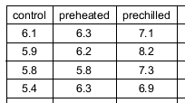 x 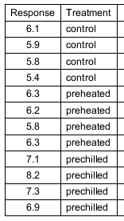

(Use of Pivot tables in Excel solves visualization issues with keeping it all in the right format (second)).

* Save as .csv
  + English windows: it’s truly a COMMA separated values file
  + Others: the separator is usually “;”
* Common errors with reading table
  + Column names cannot have spaces (for instance a column name “Sample pH” would cause the process to fail)
  + Factors can only have spaces if you are not using a space as the separator (file is a csv or separator is “;”)
* If you use space as a separator, then missing values must be substituted first to NA

## Getting data in and out of R

* setwd(); getwd()
* DATA IN: read.table(); read.csv(); read.csv2()
  + library(foreign) for other types
* DATA OUT: write.table(); save(); save.image()
* read.csv2
* read.table(“file.name.xxx”,sep=”;”, header=TRUE)

## Object manipulation and the R environment

* The R environment : ls()
* Save environment: save.image(file="myfile.RData")
* Load environment
  + load("Rmeeting.RData ")
* rm(), keep()

### Script used in video5:

## Right data format in Excel

## Data in

getwd()

setwd() #set manually

#projects in RStudio

#pasted from Explorer:

#C:\Users\dorea.meyer\mydata

#setwd("C:\\Users\\dorea.meyer\\mydata")

#setwd("C:/Users/dorea.meyer/mydata")

?read.table

weight.data <- read.csv("animal_weights.csv")

# weight.data <- read.csv(

# "C:/Users/dorea.meyer/mydata/animal_weights.csv")

#weight.data <- read.csv2("animal_weights.csv")

#weight.data <- read.csv("animal_weights.csv", sep=";", dec=",")

str(weight.data)

weight.data <- read.csv("animal_weights.csv",

stringsAsFactors=FALSE)

str(weight.data)

#row.names

#col.names

## NAs

is.na(weight.data)

weight.data[weight.data==""]<- NA

is.na(weight.data)

#install.packages("foreign")

require(foreign)

help(package="foreign")

unique(weight.data)

duplicated(weight.data)

duplicated(weight.data[,2:4])

complete.cases(weight.data)

summary1 <- mean(weight.data$weight)

summary2 <- aggregate(Weight ~ Group,

FUN="mean",

data=weight.data)

#Data out

write.table(weight.data,file="weight.data.csv",

sep=",") #getwd()

#row.names, col.names

save(weight.data,file="weight.data.RData")

save.image(file="weight.data.RData")

#Save workspace using RStudio

#clear workspace

rm(list=ls())

#Load saved files or workspace

load("weight.data.RData")

#rm()

#keep()

## Use of an editor to save scripts

* #comments
* Load a batch of code: warning x errors
* Head
  + rm(list=ls())
  + packages
  + setwd() ; getwd()
* Import data
* Analysis
  + Align commands
  + Organize levels
  + USE comments
* Export data
* Save image

## RStudio and scrip management

* R PROJECT
* All types of files
* Sections, chunks, etc
* Collapsible code

## Graphs

* Plots with two continuous variables
  + plot()
  + lines()
  + labels
  + points()
  + text()
  + arrows()
  + polygon()
  + pch
  + legend
  + col

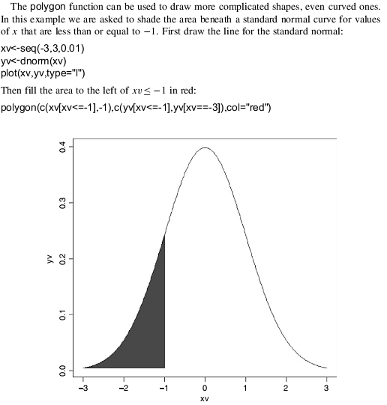

* Plots with a continuous and a categorical variables
  + Box-plot - Plot(catX,y)
  + Bar plot – barplot(y)
* Plot for a single variable
  + hist()
    - breaks=
    - adding distribution line: (calculate parameters first – p.e. mean, stdev, then use dxxx) 🡪 lines (xrange,ys*xlength)

## Working with dates

There are two basic classes of date/times. Class POSIXct represents the (signed) number of seconds since the beginning of 1970 as a numeric vector: this is more convenient for including in dataframes. Class POSIXltis a named list of vectors closer to human-readable forms, representing seconds, minutes, hours, days, months and years.

* Sys.time() date()

> class(date()) [1] "character"

> class(Sys.time()) [1] "POSIXct" "POSIXt"

> date<-as.POSIXlt(Sys.time())

> date [1] "2013-01-11 10:35:28 CET"

> date$sec [1] 28.45003

> date$min [1] 35

> date$hour [1] 10

> date$mday [1] 11

> date$wday [1] 5

> date$yday [1] 10

* + Months: 0 to 11
  + Weekdays: 0 to 6
* Type in time
* Recognizing time – strptime

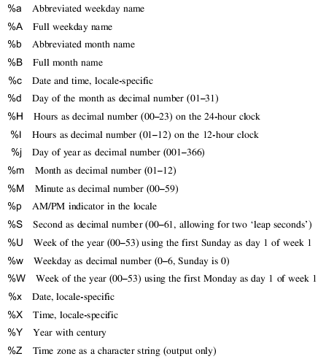

* strptime(excel.dates,format="%d/%m/%Y")

## Loops and conditional execution

* Standard logical operations are "&" (and), "|" (or), and "!" (negation)
  + help("&")
* if (expr_1 ) expr_2 else expr_3
* ifelse(condition, a, b)
* for (name in expr_1 ) expr_2
  + break
  + next
* while (condition ) expr
* avoiding loops – use of vector functions
  + for (i in 1:length(y)) { if(y[i] < 0) y[i] <-0}
  + versus: y[y<0]<-0
* Do not ‘grow’ data sets in loops or recursive function calls